1. |  | What is the physical interpretation of Pointing vector?
2. |  | Derive an expression for curl of a vector.
3. |  | What is excess-3 code?
4. | Identify the operation of the following logic circuit.  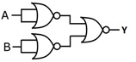
  5. | Define multiplexer.
  6. | Encode the 11-bit code 10111011101 into 15 bit information code?
  7. | State Gauss law for electric fields.
  8. | Give BCD for decimal number 96.42.
  9. |  | What is a travelling wave?
  10 |  | What is the principle of a waveguide?
  11. |  | What is divergence of curl of a vector?
  12. |  | What is the Boolean expression of the output of the logic circuit shown in figure?  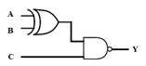
    13. Derive an expression for curl of a vector.
    14. State Gauss law for electric fields.
    15. State coulombs law.
    16. State stoke’s theorem
    17. Discuss about curl of a vector.
    18. What is divergence of curl of a vector?
    19. What is the relation in between the conduction current density and the conductivity of a medium?
    20. Find the relation between electrostatic potential and electric field intensity?
    21. What is the phase difference between electric field vector and magnetic field vector in an electromagnetic wave?
    22. What is the condition for magnetic potential be scalar?
1. |  | Find out Y for the following network.  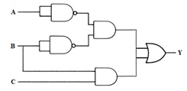 | 3
. |  | Obtain the output of the combinational circuit given below.  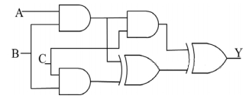 | 3
3. |  | Digital circuit using two inverters shown in figure acts as which multivibrator?  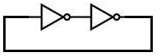 | 3
4. |  | Determine the number of NAND gates required to implement X-OR function. | 3
  5. Which gate is represented by the following circuit?
  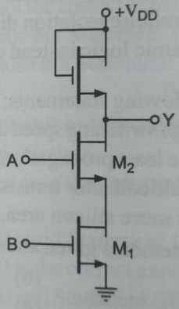
  6. | Solve the Boolean expression using K –map?  Y =(WXYZ)= 𝝅M(1,2,3,4,5,7,9,12,13,14,15) & φ ( 6,10,13)
  7. | Define electric flux & electric flux density.
  8. | State Gauss law for electric fields.
    9. The Boolean function Y = AB + CD is to be realized using only 2 - input NAND gates. Determine the minimum number of gates required.
    10. Determine the number of NAND gates required to implement X-OR function.
    11. Solve the Boolean expression using K –map in SOP method
    F(ABCD) =∑M(4,5,6,7,8,9,10,11,12,13,14,15)
    12. Define Half adder and full adder.
1. |  | If the electric field intensity is given by E = (xu_{x}+yu_{y}+zu_{z}) volt/m, find the potential difference between X(2,0,0) and Y(1,2,3). | 5
2. |  | Derive the relation between electric intensity E, voltage applied V and the distance d between the plates of a parallel plate condenser. | 5
3. |  | Minimize the following expression in SOP form using K-Map: F(A, B, C, D) = Σ m(1,2,3,8,9,10,11,15) + Σ d(7,14). | 5

4. | Calculate the value of line integral $\int_{P}^{Q}{(z^{2}dx+3 y^{2}dy+2 xz dz)}$ along the straight line joining the points P (1, 1, 2) and Q (2, 3, 1).
5. | The direction of vector A is radially outward from the origin, with |A| = k$r^{n}$ where $r^{2}= x^{2}+ y^{2}+ z^{2}$ and k is constant. Calculate the value of n for which $∇.A=0$.
6. | Simplify the expressions using K-map:  F = m(0,3,5,6,12,15) + d(1,10,13)  F = m(0,2,3,5,6) + d(4,7,8).

7. | Give the output of the combinational circuit given below.  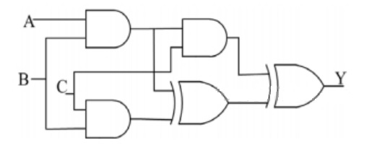
8. | For the circuit shown, obtain the Boolean expression for output Y.  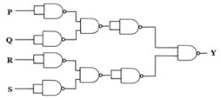
9. | Consider a lossless transmission line with characteristic impedance Z₀ = 50 ohm, If the line is terminated with a load impedance of 80 ohm, determine the minimum input impedance of the line?

